Title: Implementation of Networking commands like ping, ipconfig, traceroute, TELNET, nslookup, ARP, RARP etc.

AIM: Implementation of Networking commands like ping, ipconfig, traceroute, TELNET, nslookup, ARP, RARP etc.
Hardware Requirement: PC with Linux Fedora/Ubuntu OS/ Windows OS
Theory:
- PING- PING (Packet Internet Groper) command is used to check the network connectivity between host and server/host. This command takes as input the IP address or the URL and sends a data packet to the specified address with the message “PING” and get a response from the server/host this time is recorded which is called latency. Fast ping low latency means faster connection. Ping uses ICMP(Internet Control Message Protocol) to send an ICMP echo message to the specified host if that host is available then it sends ICMP reply message. Ping is generally measured in millisecond every modern operating system has this ping pre-installed
- Traceroute/ Tracert- The traceroute/tracert command is used in Linux to map the journey that a packet of information undertakes from its source to its destination. One use for traceroute is to locate when data loss occurs throughout a network, which could signify a node that's down. Because each hop in the record reflects a new server or router between the originating PC and the intended target, reviewing the results of a traceroute scan also lets you identify slow points that may adversely affect your network traffic.
- TELNET- Terminal Network (TELNET) is a computer protocol that was built for interacting with remote computers. The word “Telnet” also refers to the command-line utility “telnet”, available under Windows OS and Unix-like systems, including Mac, Linux, and others. We will use the term “Telnet” mostly in the context of the telnet client software. Telnet utility allows users to test connectivity to remote machines and issue commands through the use of a keyboard. Though most users opt to work with graphical interfaces, Telnet is one of the simplest ways to check connectivity on certain ports.
- NSlookup: The nslookup command is used to query Internet name servers interactively for information. Nslookup (stands for “Name Server Lookup”) is a useful command for getting information from DNS server. It is a network administration tool for querying the Domain Name System (DNS) to obtain domain name or IP address mapping or any other specific DNS record. It is also used to troubleshoot DNS related problems. It is used to query specific DNS resource records (RR) as well. Most operating systems comes with built-in nslookup feature.
- Netstat: Netstat (network statistics) is a command line tool for monitoring network connections both incoming and outgoing as well as viewing routing tables, interface statistics etc. Netstat is available on all Unix-like Operating Systems and also available on Windows OS as well.
Netstat is very useful in terms of network troubleshooting and performance measurement. Netstat is one of the most basic network service debugging tools, telling you what ports are open and whether any programs are listening on ports. This tool is very important and much useful for Linux network administrators as well as system administrators to monitor and troubleshoot their network related problems and determine network traffic performance

- ARP: Address Resolution Protocol (ARP). The ARP command could be used for the following purposes:
  - Display IP address to MAC address resolution information for neighboring devices.
  - Clear address mapping entries and set them up manually.
  - Add an address for which to proxy arp.
  - Forcefully add permanent entries to the ARP table.
- RARP: Reverse Address Resolution Protocol (RARP), manipulates the kernel’s RARP table in various ways. The primary options are clearing an address mapping entry and manually setting up one. For debugging purposes, the RARP program also allows a complete dump of the RARP table.
Procedure:
- To study the Linux commands, open the terminal and execute the following commands with different options.
PING COMMAND

- To use ping command: Basic usage is fairly easy just execute the 'ping' command with destination as input.
Syntax
$ ping URL
$ ping IP address
Ex: Ping www.google.com
Ping 10.10.75.211
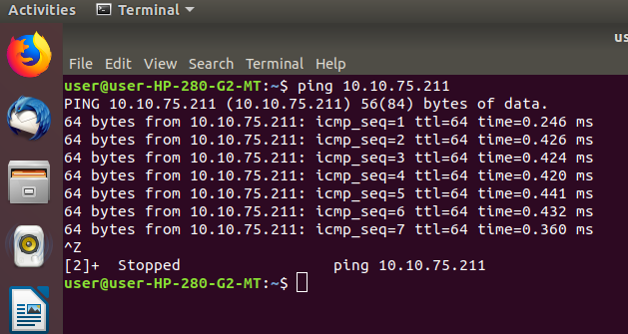
- To change time interval between ping packets: By default, there's a gap of one second between ping packets. However, if you want, you can customize this delay using the -i command line option. For example, the following command makes sure there's a gap of 3 seconds
Syntax
$ ping -i (time in sec) URL/IP address
Example: $ ping -i 3 10.10.75.211
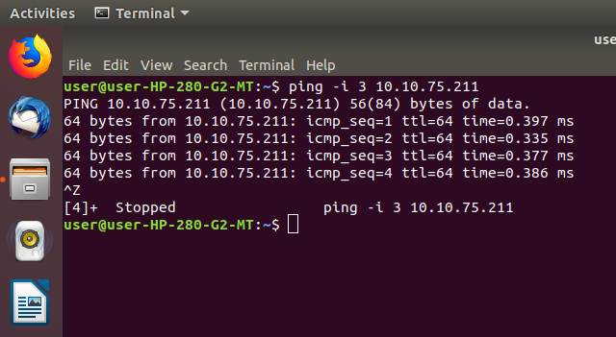
- To change ping packet size: By default, the number of bytes in a ping packet is 56 (64 if you include 8 bytes of ICMP header). However, if you want, you change this value, something which you can do using the -s command line option.
Synatx
$ ping -s (Size) URL/IP address
Example : To send an 70 byte packet (88 including ICMP header), use the following command
$ ping -s 70 10.10.75.211
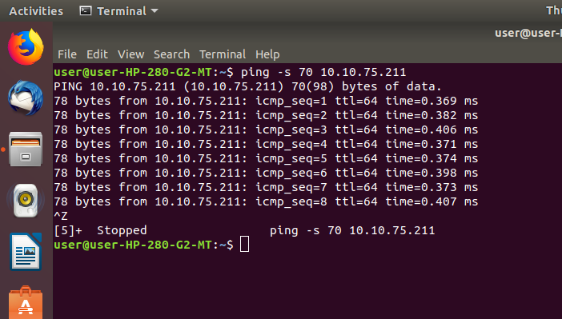
- To make ping send set number of packets: The default behavior of ping is to keep sending packets until interrupted by the user. However, if you want, you can force ping to stop executing after sending a set number of packets. This you can do using the -c command line option.
Synatx
$ ping -c (no of packets) URL/IP address
Example: The following command will send 3 packets and then stop.
$ ping -c 15 10.10.75.211
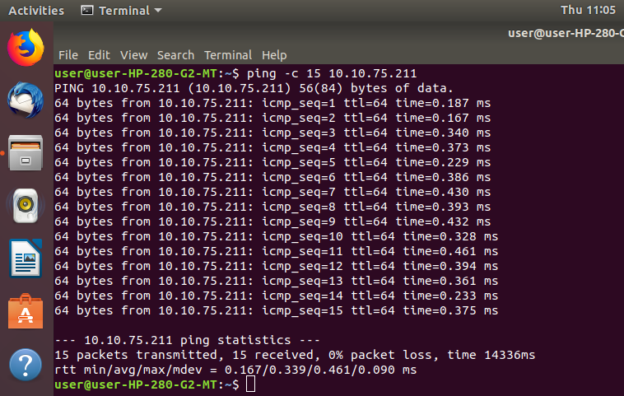

- To make ping print timestamp before each line: The timestamp that's printed is a combination of unix time and microseconds (as in gettimeofday).

Syntax
$ ping -D URL/IP address
Example: The following command will set timestamp
$ ping -D 10.10.75.250
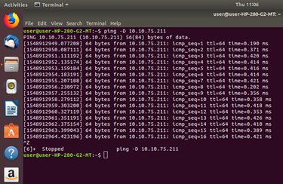
- To enable broadcast: To enable pinging a broadcast using the -b as shown.
Syntax
$ ping -b URL/IP address
Example: The following command will enable timestamp
$ ping -b 10.10.75.211
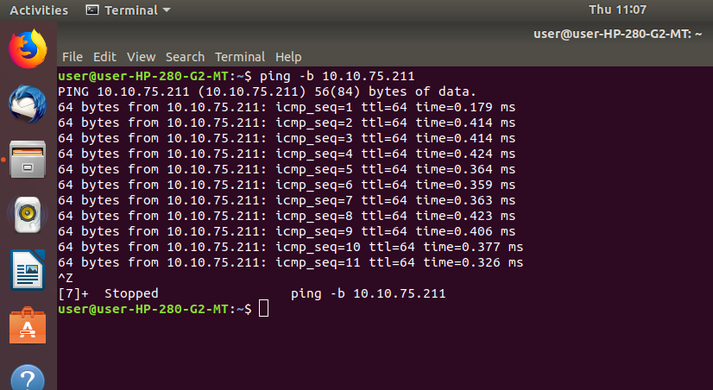
- To limit the number of network hops: The number of network hops (TTL – Time-to-live) that probes traverse, use the -t flag. You can set any value between 1 and 255; different operating systems set different defaults.
Syntax
$ ping -t 10 URL/IP address
Example,: The TTL has been exceeded and the ping test has failed
$ ping -t 10 www.google.com
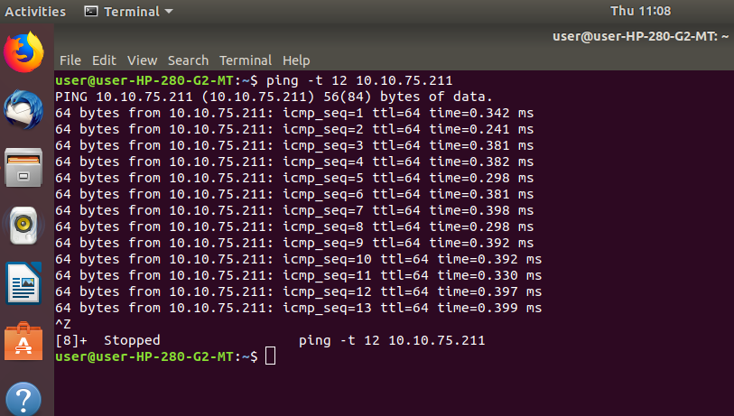
- Flooding the Network: Ping command allows super users to send 100 or more packets per second through the following command:
Syntax
$ sudo ping -f hostname-IP
Example: $ sudo ping -f www.google.com

- To Set ping timeout: You can set a time limit after which ping will exit; no matter how many ping packets are sent or received
Syntax
$ ping -w timeinseconds hostname/ip
Example: The following command will set 3 timeout.
$ ping -w 10 10.10.75.211

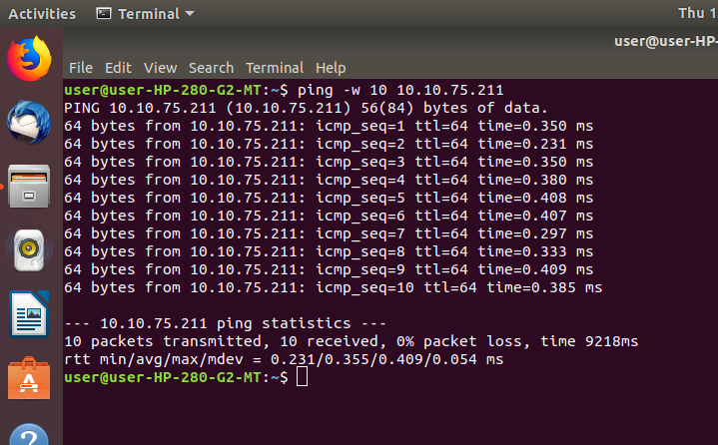
- Audible ping: The ping command can be set to play a beep to check whether the host is available as follows:
$ ping -a hostname/ip
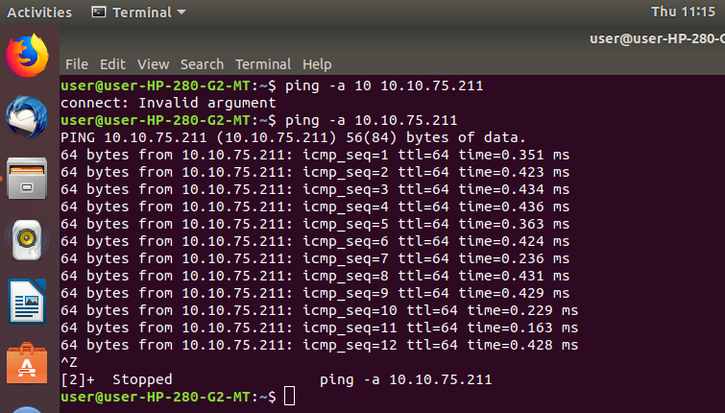

TRACERT/TRACEROUTE:
- The syntax is
traceroute [options] host [ packetlen ]
- To find the route to the given destination: To find the route to the given destination like host, IP address, website etc. the syntax used is
Synatx
$ traceroute URL/IP address
- Show IP Address Do Not Resolve Host Name: The -n option can be used to disable host name resolution.
Synatx
$ traceroute -n URL/IP address
$ traceroute -n 10.10.75.211
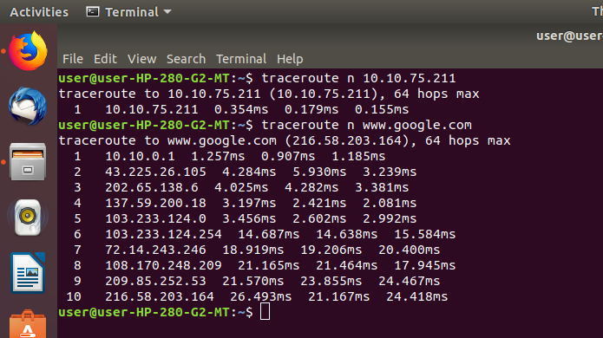

- To Set Response Time: To set time for the response and make our network trace operation more faster the command used is
Synatx
$ traceroute -n -w time in sec) URL/IP address

Example: To set timeout for the trace 1 second with -w option, the following command is used
$ traceroute -n -w www.google.com

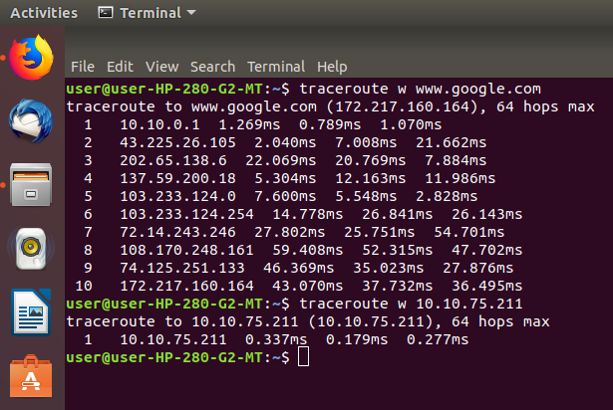

- To Set Number Of Queries Per Hop: Traceroute by default makes 3 query for each hop. This is changeable property. This can be changed with -q parameter.

Syntax
$ traceroute -n -q (no of queries) URL/IP address
Example: In the following example we set query count as 1 for each hop.
$ traceroute -n -q 1 10.10.75.211

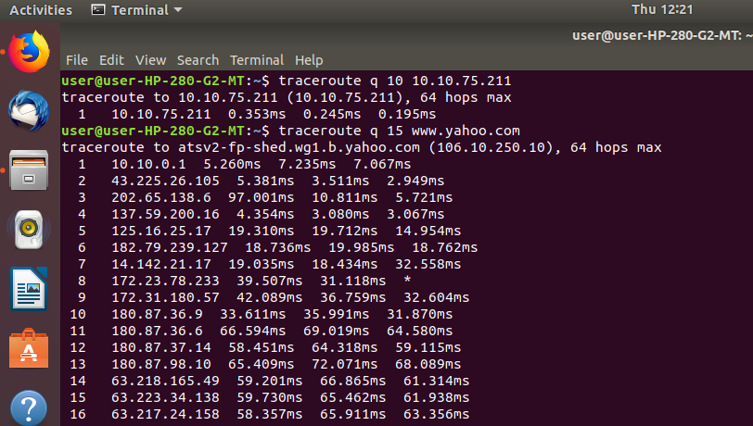
TELNET:
- To Connecting to the TELNET server: User can connect with the Telnet by using the hostname or IP of the host.
Syntax
$telnet Hostname/Ip Address
Example : $telnet 10.20.208.110
- Without using Hostname or Ip Addres: User can also connect with the Telnet without using the hostname or IP of the host.
Syntax
$telnet
telnet>Open hostname/IP address
NSLOOKUP
- To Find out “A” record (IP address) of Domain: nslookup followed by the domain name will display the “A Record” (IP Address) of the domain.
Syntax
$ nslookup URL
Example: The query domain www.yahoo.com with 4.2.2.2 public DNS server and below section shows Non-authoritative answer: displays A record of www.yahoo.com
$ nslookup www.google.com
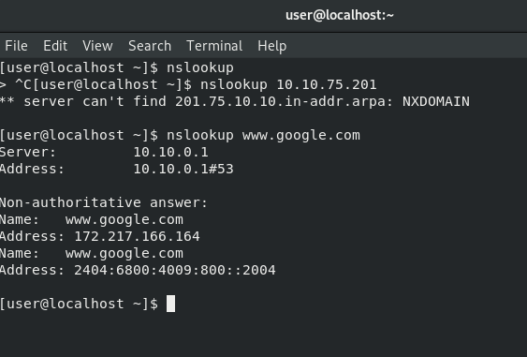
- Reverse nslookup: Reverse DNS lookup You can also do the reverse DNS look-up by providing the IP Address as argument to nslookup.
Syntax
$ nslookup IP address
- To find out specific Domain Lookup: To find out the specific Domain Lookup the following command is used
Syntax
$ nslookup Domain
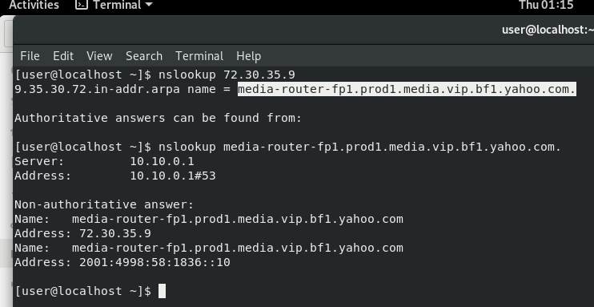
- To Query MX (Mail Exchange) record: MX record is being used to map a domain name to a list of mail exchange servers for that domain. So that it tells that whatever mail received / sent will be routed to mail server.
Syntax
$ nslookup -query=mx URL

Example: To find the MX record for www.yahoo.com the following command is used
# nslookup -query=mx www.yahoo.com
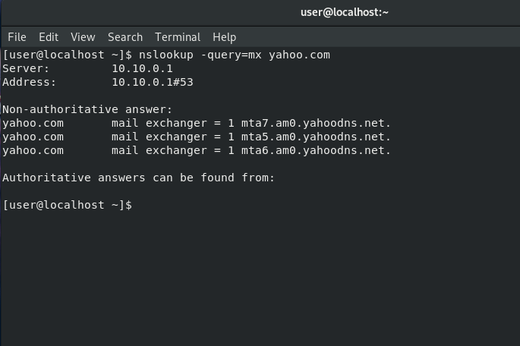
- To query NS(Name Server) record: To query name server the following command is used
Syntax
$ nslookup -query=ns URL

Example: To find the NS record for www.yahoo.com the following command is used
# nslookup -query=ns gmail.com
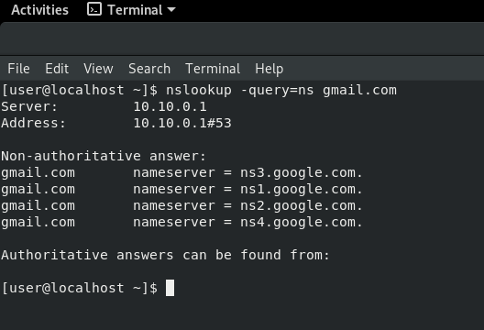

- To lookup for SOA records: Lookup for an SOA record (start of authority), provides the authoritative information about the domain, the e-mail address of the domain admin, the domain serial number, etc.
Syntax
$ nslookup -type=soa URL
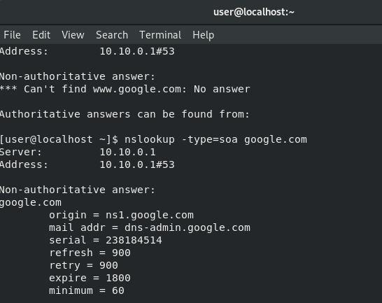

- To query all Available DNS records: To query all Available DNS records the following command is used
Syntax
# nslookup -query=any URL
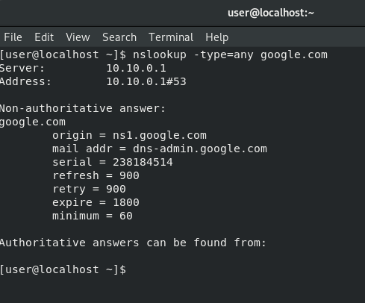

NETSTAT:
- To listen all the LISTENING Ports of TCP and UDP connections, the following command is used
Syntax
$ netstat –a
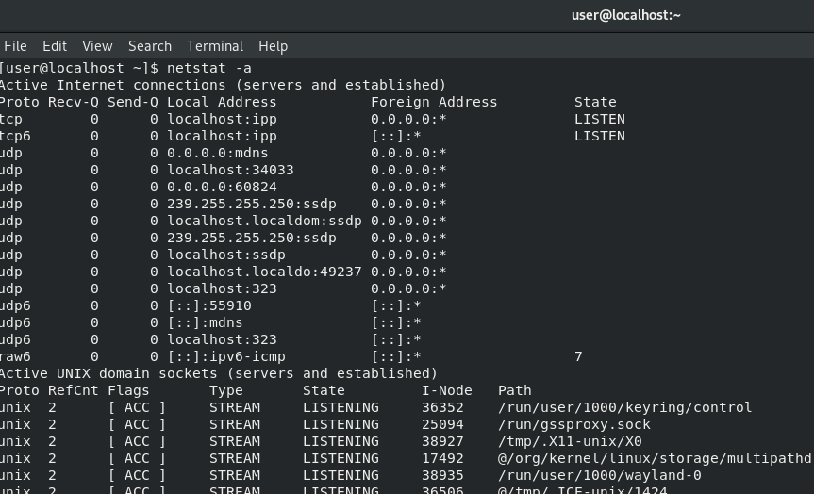
- To listen only TCP (Transmission Control Protocol) port connections , the following command is used
Syntax
$ netstat –at
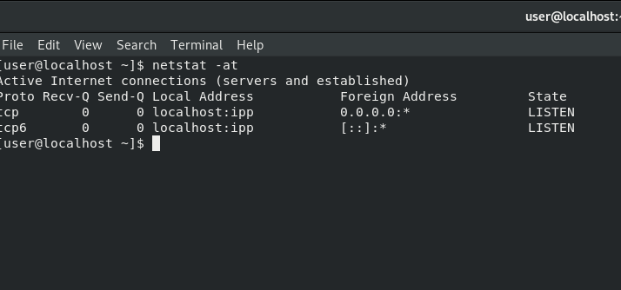
- To listen only UDP (User Datagram Protocol ) port connections using the following command is used
Syntax
$ netstat –au
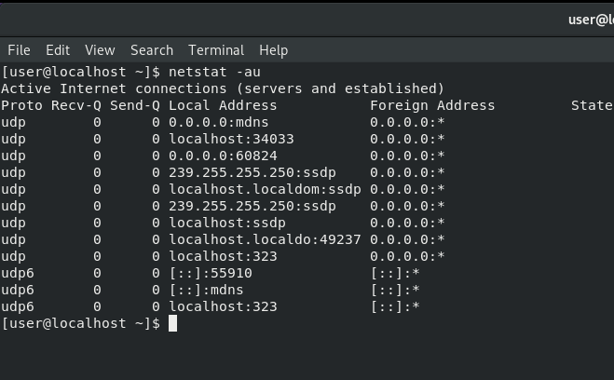
- To listen all active listening ports connections the following command is used
Syntax
$ netstat –l
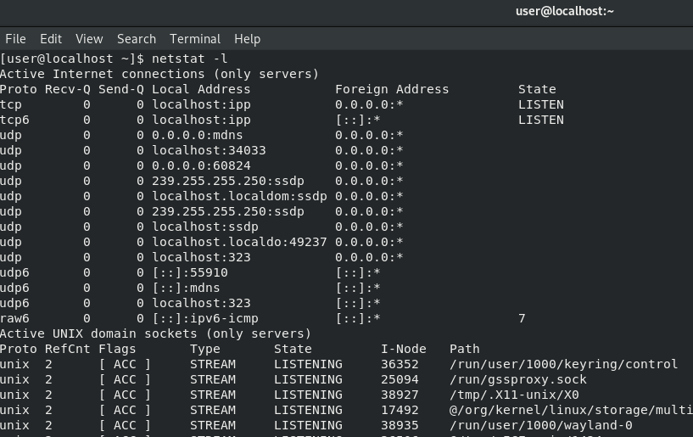

- To listing all active listening TCP ports following command is used
Syntax
$ netstat –lt
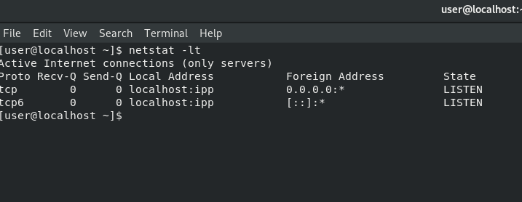
- To listing all active listening UDP ports following command is used
Syntax
$ netstat –lu
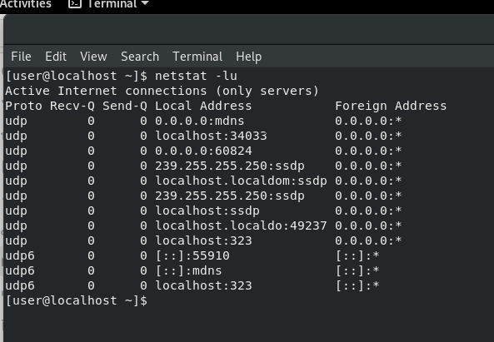

- To Show Statistics by TCP Protocol following command is used
Syntax
$ netstat –st
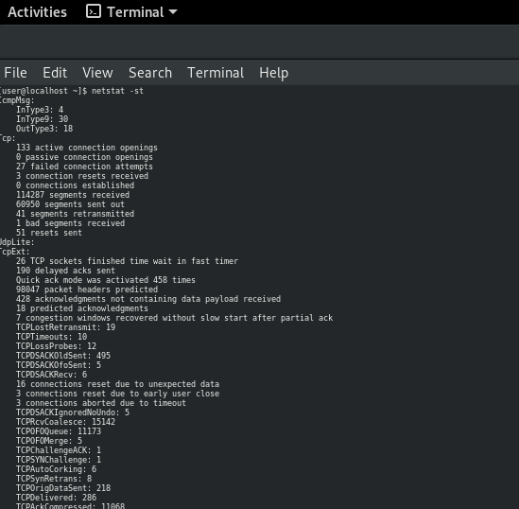
- To Show Statistics by UDP Protocol following command is used
Syntax
$ netstat –su
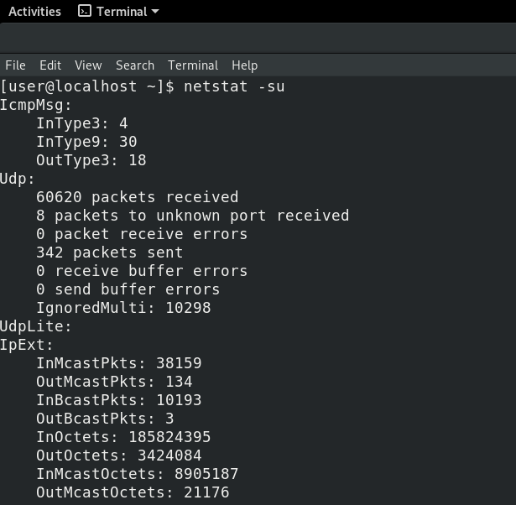

ARP(Address Resolution Protocol):
- To Display entries/; Invoking the ARP command without any options will display the contents of the ARP cache table
Syntax
& arp
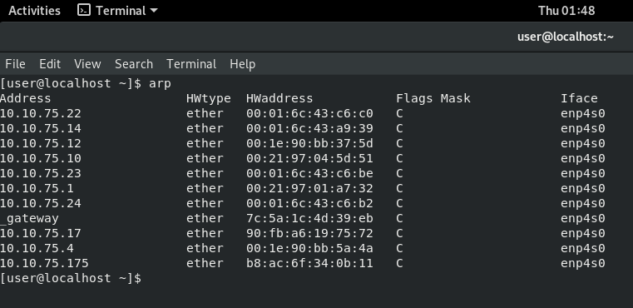
- To Display entries for particular addresses: If we have a large arp cache and need to get entries for a particular IP address then we could do so by using the arp command with the -a option followed by the IP address.
Syntax
$ arp –a IP address
Example:
$ arp -a 10.10.75.23
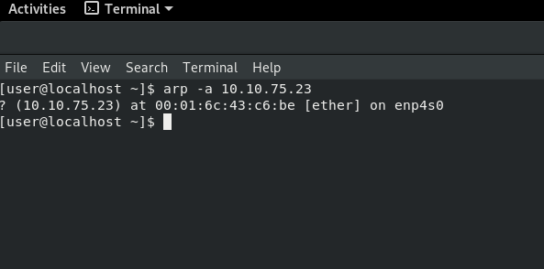
- Display ARP entries for an interface: If we wish to display arp entries for only a single interface then we could do so by invoking the arp command with the -i option followed by the interface name
Syntax
$ arp –i IP address
Example
$ arp -i 159.254.171.22
RARP(Reverse Address Resolution Protocol):
- To Display the version of RARP in use the syntax used is
Syntax
$rarp -v

Title: Implement Linux Network Configuration Commands.
a. Configuring NIC’s IP address.
b. Determining IP address and MAC address using if-config command.
c. Changing IP address using if-config command.
d. Static IP address and Configuration by Editing.
e. Determining IP address using DHCP.
f. Configuring Hostname in /etc/hosts file.

AIM: Implement Linux Network Configuration Commands.
a. Configuring NIC’s IP address.
b. Determining IP address and MAC address using if-config command.
c. Changing IP address using if-config command.
d. Static IP address and Configuration by Editing.
e. Determining IP address using DHCP.
f. Configuring Hostname in /etc/hosts file.

Hardware Requirements: PC with Linux Fedora/Ubuntu OS.
Procedure:
- Congiguring NIC’s IP address.
- Open networking and sharing center. Now ,open wired settings
- Check whether wired connection is ’ON’ or ‘OFF’. If it is OFF, then press the button and ON the connection
- Go to settings ,select IPv4 by manual method.
- Give the IP address as 10.10.75.211, netmask, Gateway, DNS and save the changes.
- Close the wired connection.
Output:
IPv4 Address:10.10.75.211
Netmask: 255.255.0.0
Gateway: 10.10.0.1
DNS: 10.10.0.1
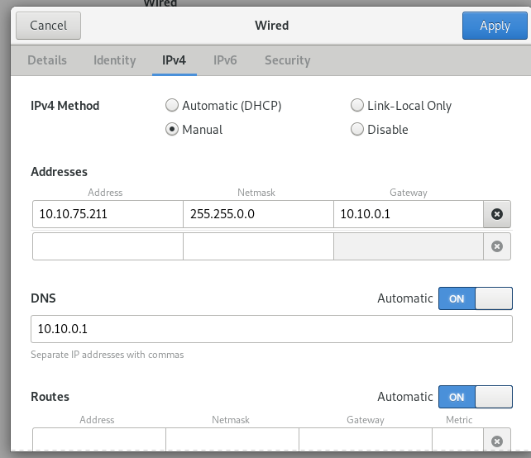

- Determinning IP address and MAC Address using ifconfig command
- Open terminal, give command as ifconfig and check for ip address and MAC address.
Output
IP Address:10.10.75.211 MAC: 70:5a:of:43:fa:df
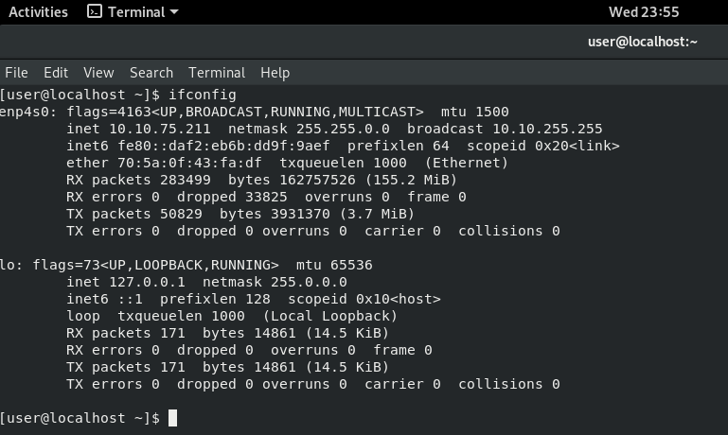

- Changing IP address using ifconfig
- Open terminal
- to login as root give the command as ‘su’
- give the password and enter
- To change the ip address ,the command is
Syntax: $ ifconfig (interfacename) ipaddress
- To check the interface name, give the command as
Syntax: $ifconfig -a
- Type the syntax as
Syntax: $ ifconfig enp4s0 10.10.75.230
And then press enter and check ifconfig for new ip address
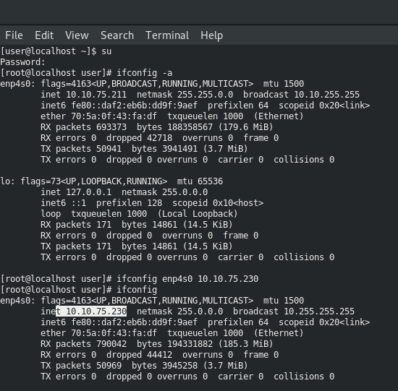

- Static IP address and configuration by Editing.
- Open terminal
- to login as root give the command as ‘su’
- give the password and enter
- now, check whether the network-scripts are installed and updated.
- To install network-scripts, give the command as
Syntax: $ yum install network-scripts
- Go to network-scripts directory, command is
Syntax: $cd /etc/sysconfig/ network-scripts
- To configure the static ip address in the terminal given the command as
Syntax: $vi ifcfg-interfacename
- Configure the ip address ( press i., come down to IPADDR=10.10.75.230) and press esc+:wq
- You should restart the network service
To restart as network service give the following commands
Syntax: $ systemctl enable network.service
$ systemctl restart network.service
$ systemctl restart NetworkManager.service
Fig: IP address before editing
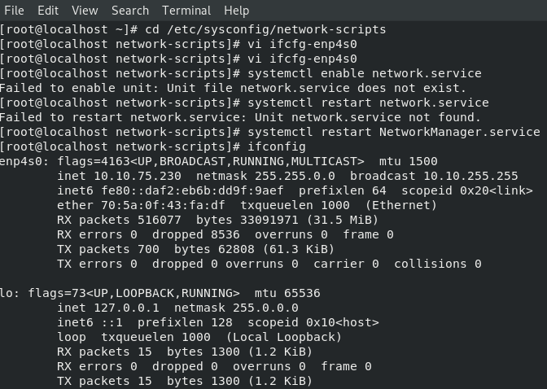
Fig: IP address after editing
- Determining IP address using DHCP
- Execute the following command from a terminal
Command: $cat /etc/ network/interfaces
- If your internal ip address is set as dynamic, it should contain
Command: $iface (interfacename) inet dhcp
- If your internal ip address is static, then the result will contain
Command: $iface (interfacename) inet static

- Configuration Host name in /etc/hosts file
- To change the hostname give the command as
Syntax: hostnamectl set-hostname (newname).

